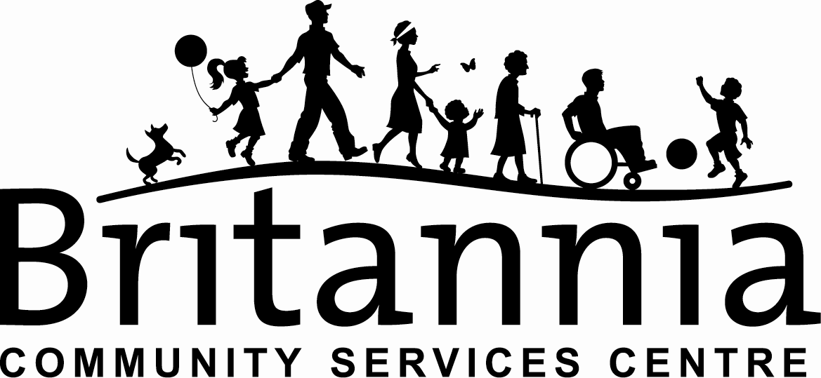

MINUTES
Seniors, Elders & Advocates Committee (SEA)
Wednesday September 16 2020 3:15pm Online Zoom

Present: Annie Daniko (Chair), Vera Jones, Cynthia Low, Teka Everstz, Maureen Matilpi, Lora Massoti, Sabian Rawcliffe, Susie Phil, Cylia Wong, Anne Cowan, Kya Prince, Daniel Cook

Opening prayer and land acknowledgement – Maureen

September Events;
- Orange Shirt Day
  - Crafting Classes were a success. Orange Shirt Day brooches were created with a description of the OSD movement, and any other ongoing events. The Brooches are to be delivered to the elementary school principle for their Orange Shirt Day event by Sept. 30th.
  - Sept. 22nd Phyllis Webstad and UBC Learning centre are hosting a speaker program via Zoom. Any who are interested can sign up with 55+ Team, and will meet afterwards for a discussion and lunch together.
- AGM
  - Sept 23rd via Zoom. Membership required to vote.
  - There are seven spots open for the Britannia Board.
  - 55+ Team have already insured our groups/classes have active memberships.
- Teka Updates
  - Pow Wow – Large in person events no longer advised as a safe course of action. Virtual event in the works.
  - Focus moving forward to MMIWG, LGBTQ+, and gender based violence victims – honouring event on awareness, advocacy, and healing
  - Presentations to be online as well as in person (w/ COVID Safety Protocols) to create safe spaces to share stories as well as support individuals who may not have access/digital divide.
  - Reaching out to community members and families on what they would like to see from these events – needs assessment
  - Honorariums and honouring bundles with resources, shirts, medicines etc.
Updates WOCT/Craft Collective;
- WOCT
  - Craft Collective meetings up and running
  - Beading and Cedar weaving classes full with strong engagement. Regular delivery schedule confirmed with new PA drivers

- HATTA
  - Virtual class will start at the end of October 2020. Confirmed class list in the works with Kya, Anne, and Todd.
  - Working on getting a small space to dance previous hats to life
- Quirk-e
  - Still meeting virtually – a small gathering in the works
Restart Updates;
- Britannia Programs Opening
  - Restricted programs and spaces up and running on a limited basis.
  - Pre-registration and approved Daily Health Assessments absolutely required for all classes/workshops/activities
  - Staff, Instructors, and Volunteers have all gone through COV approved training and orientation on operation and onsite programs
  - Flu clinic in talks of running again this year on site – updates to come
- New Horizons Seniors opening – Proposal of virtual and in person programming updates to be sent out by Cynthia to SEA members
- Renewal
  - Correspondence being done with community members
  - Seniors requirements and needs assessment should be brought to Renewal Meetings
  - Rezoning meetings underway – housing needs feedback can be sent to Annie and Cynthia for the Renewal Committee
  - Next meeting invite will be posted on website
- Indigenous Garden
  - Redevelopment plan for Carving Pavilion with Teka and Britannia
  - Inviting local community members to advise and support with project
  - New design approach for workshops, community engagement, cultural knowledge sharing, and capacity building.
  - Searching for members/organizations to actively participate. Knowledge keepers, language keepers for identifying and medicines teaching. Gardeners for design and layout options, inventory of existing plants, transporting and harvesting.
  - Meeting invites to be posted online
Next SEA Meeting: October 21st 2020 3:15pm through Zoom

