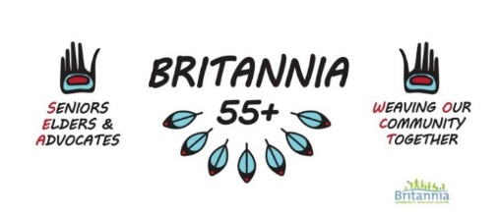

Seniors, Elders & Advocates Committee (SEA)
Wednesday November 16, 2022
3:30pm In-Person at Britannia 55+ Centre and online via Zoom

Zoom: https://us02web.zoom.us/j/85794432058
Mtg ID: 857 9443 2058
Dial In: 778 907 2071

Present:

55+ Upcoming Programs and Updates
  - Registration Dates for Winter Programs
    - In person and online - Tuesday Dec 6th 7:00pm
    - By phone – Wednesday Dec 7th 9:00am
  - Britannia Winter Craft Market
    - Friday Nov 18th 3pm-8pm (Kya) & Saturday Nov 19th 10am-6pm (Daniel)
    - In Gym D ($6) & 55+ Centre (Free Entry)
    - Sign Up Sheet for Tables and Volunteers
  - Christmas Luncheon with Ukulele Chorus ($6) Dec 19th
  - Monday Soup Lunch Program
    - Last day Dec 16th - Starts up Jan 9th
  - Thursday Hat Weaving
    - Last Class Dec 22nd
    - New Set Jan 12th
  - Thursday Crafts
    - Last day Dec 15th - Starts up Jan 5th
  - Friday Social
    - Last Day Dec 16th - Starts up Jan 13th
  - Friday Chair Yoga
    - Last Class Dec 9th
    - New set Jan 6th
  - WOCT
    - Indigenous crafts – dec.12
    - Drum circle – dec.19
    - Cedar weaving – dec.16
  - Craft Collective
    - Next meeting date Thursday Nov 17th
  - Quirke
    - Land Acknowledgement discussion - Tabled
  - VPL
    - Possible drum workshop with Sabian. Dates, times and how to sign up are being worked out by Daniel and Randy. More info to come.
IRSSS
  - Paulena Smith, Resolution Health Support Worker, will be onsite on Monday’s (and any specified days) while Vera Jones is on leave

Does SEA Committee want to meet in December 2022 *

