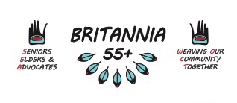
Seniors, Elders & Advocates Committee (SEA)
Wednesday July 20, 2022 3:30pm Hybrid

Extreme Heat Safety Workshop - REACH Community Health Centre Partnership
- Faith Tang led the 1 hour long workshop, with slides and info handouts available. This workshop also had “Cooling Kits” ready made and available for each participant attending. Any who wish to inquire about collecting one may speak to 55+ Centre Staff
- Contact Faith at ftang@reachcentre.ba.ca or 604-245-3838 to book a workshop for yourself, a group, or your organization during July-August 2022.

Orange Shirt Day Planning – Sept 30th
- SEA asked to oversee finding an MC, host Nation welcome, drummers, honour gifts, etc.
- It is a STAT Holiday for full/part-time staff. Who on the auxiliary staff will be available?
- The Anti Racism and Anti Oppression committee and planning group are to take care of logistics; refreshments for 55+ centre, start of walk at VAFC, route flaggers, working with VPD, PA, tents, chairs, tables, food (soup, bannock, cookies, fruit) water, set up, take down ,clean etc.

5 year RIA Committee – Working Group and Hiring Committee has been assembled.

Meeting adjourned

Next SEA Meeting: 3:30pm Wednesday August 17, 2022

