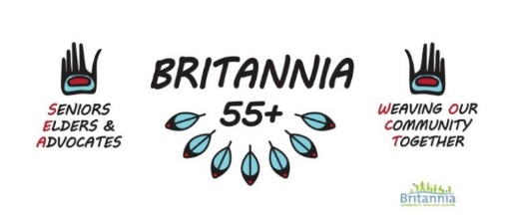

Seniors, Elders & Advocates Committee (SEA)
Wednesday September 21st, 2022
3:30pm In-Person at Britannia 55+ Centre and online via Zoom

Zoom: https://us02web.zoom.us/j/85794432058
Mtg ID: 857 9443 2058
Dial In: 778 907 2071

AGENDA

- Opening Prayer and Land Acknowledgement

- Orange Shirt Day – Friday September 30th 2022
  - MC Suggestions
  - Agenda
  - Vendors

- 5 Year Plan
  - Updates

- Lytton Fundraiser Update

- Program Updates
  - 55+ Fall Programs
  - WOCT
  - Quirk-e
  - VPL

- Additions

Next Meeting: Wednesday October 19th 2022

