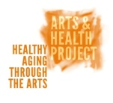
Letter of Interest

Aboriginal Elders Arts Project

Elders will work with artist Todd DeVries on weaving projects starting July 2021. Space will be limited - please let us know about your interest, and we will confirm registration details as soon as we can! You may also contact us at Britannia Community Centre 604-718-5837.

Thursdays – 1:30-4:00pm for 15 weeks
Online through Zoom - Britannia Community Centre (Link will be sent prior to class)

Your Name
Your Address
Telephone Number
Email Address

Aboriginal Ancestry: First Nations Metis Inuit Non-Aboriginal

If First Nations/Non-Aboriginal, please indicate which nation/nationality. ________________________________________________________________________

Please let us know why you would like to be part of this group.
________________________________________________________________________________________________________________________________________________________________________________________________________________________________________________________________________________________________________________________________________________________________________

What do you hope to gain from participating in this program?
________________________________________________________________________________________________________________________________________________________________________________________________________________________________________________________________________________________________________________________________________________________________________

What part of your culture specifically do you hope to connect with, through this program?
________________________________________________________________________________________________________________________________________________________________________________________________________________________________________________________________________________________________________________________________________________________________________________________________________________________________________________________________________________________________________________________

Are you interested in participating in celebrations and community sharing?
________________________________________________________________________________________________________________________________________________________________________________________________________________________________________________________________________________________________________________________________________________________________________________________________________________________________________________________________________________________________________________________

Anything else you would like to share about yourself, please use the space below.
________________________________________________________________________________________________________________________________________________________________________________________________________________________________________________________________________________________________________________________________________________________________________________________________________________________________________________________________________________________________________________________________________________________________________________________________

Can you make the commitment to attend the workshops every Thursday online?
________________________________________________________________________________________________________________________________________________________________________________________________________________________________________________________________________________________________________________________________________________________________________________________________________________________________________________________________________________________________________________________

IN CASE OF EMERGENCY INFORMATION

Birth Date (M/D/Y):

BC Care Card (Medical Card) #:

Emergency Contact:
Relationship:
Telephone:

Are there any medical conditions our team should be aware of? Yes No

If so, please describe: ___________________________________________________________________________________________________________________________________________________________________________________________________________________________________________________________________.

Name/Phone of physician: _______________________________________________

Are there allergies we should be aware of? Yes No

If so, please describe: ___________________________________________________________________________________________________________________________________________________________________________________________________________________________________________________________________.

Is the Arts & Health Project/Britannia Community Centre permitted to use your photo as part of website promotion or other? Yes No
(If yes, please fill out the next form.)

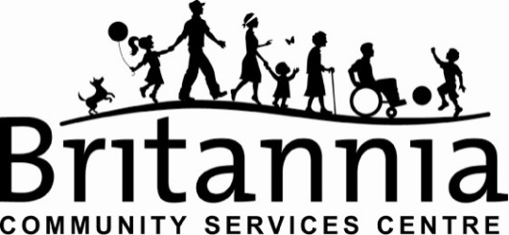

Britannia Community Services Centre
Photo Release Form

This release form will allow the use of the signer’s photograph for the promotion and marketing of Britannia park and recreation programs and facilities. Examples of such usage would include publications like annual reports, tourism brochures, leisure activity guides in print advertising and on our website/s. Would you be willing to be voice or video recorded for our Britannia Stories Project.

We will not release names or give any other information out regarding the identification of individuals in the photos without their prior consent.

My signature below means I understand that the photographs and/or video footage taken of me may be used for promotional and archival purposes for the ongoing work of Britannia Community Services Centre and Child Care Programs. I also understand that I will not be paid for the use of my image. I consent to this usage as set out above and I release the authorized photographer and/or videographer, Britannia Community Services Centre from any and all claims I may have in connection to the photographs and their usage.

- Name (please print) __________________________________________

Signature or X here ______________________________________________

Date _________________________________________________________

